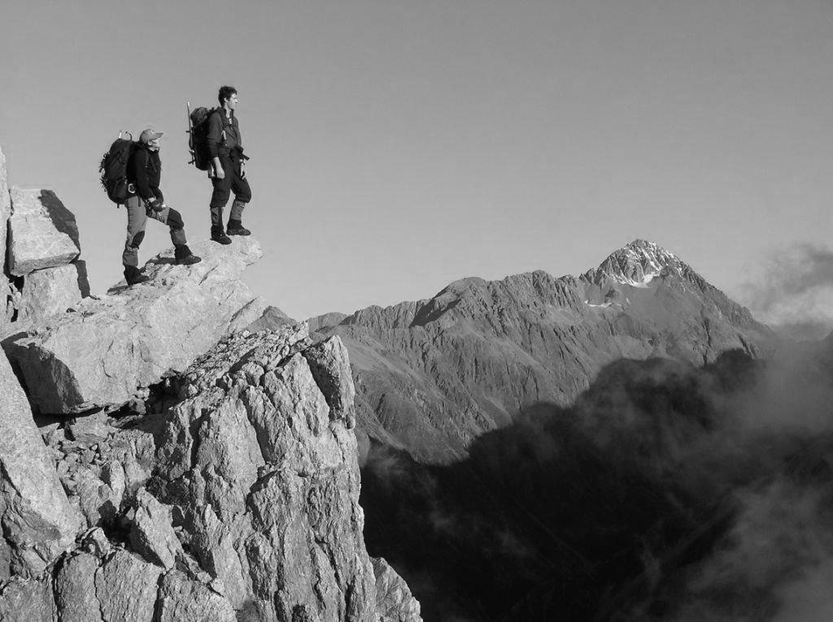

Photo: Don Paterson | Three Pass Tramp
Excellence Awards

Nomination Form 2025 (Judging period: 1 July 2025 – 30 June 2026)
The NZOIA Excellence Awards recognise the highest achievements of individuals involved in outdoor recreation, education and guiding in New Zealand. There are five awards: Emerging Instructor, Emerging Guide, Tall Tōtara, Wahine Toa, and Life Member.

Process
1 April 2026: Nominations open
30 June 2026: Nominations close | Email to: awards@nzoia.org.nz
26 September 2026: Recipients announced at the NZOIA Excellence Awards Dinner at the Symposium.

Criteria

Emerging Instructor
Awarded to an instructor who displays great potential for the future, and who demonstrates strong commitment to professional development and qualification acquisition. The ideal recipient will have at least one NZOIA qualification and be recognised as a talented instructor who stands out from the crowd.
- An instructor in their first 5 years of employment in the outdoor industry.
- A 3 or more year commitment to working as an instructor or outdoor educator
- Current NZOIA qualification holder
- Two referees
- Outstanding amongst their peers
- Demonstrated commitment to personal outdoor recreational participation and a high achiever (relative to age and experience)
- Role models a commitment to sustainable environmental practices

Emerging Guide
Awarded to an emerging guide who displays great potential, talent and commitment to a guiding career in the tourism sector. The ideal recipient should demonstrate a commitment to professional development and qualification acquisition and will have at least one NZOIA qualification.
- A guide in their first 5 years of employment in the guiding/tourism industry
- Has displayed a commitment to working in the guiding/tourism sector long term
- Current NZOIA qualification holder
- Has two referees
- Outstanding amongst their peers
- Gains consistently good feedback from clients and peers
- Role models a commitment to sustainable environmental practices

Tall Tōtara
Awarded to a current instructor or guide who personifies 'excellence in outdoor leadership'. A highly respected role model, someone who has contributed significantly to outdoor education in New Zealand through both work with clients and with aspirant instructors/guides.
- Currently active as an instructor/guide
- Well regarded by peers as an inspirational role model, and someone who constantly strives for improvement and excellence
- Outstanding mentoring of aspirant instructors/guide
- A minimum of two referees from different perspectives are required e.g. employer, peer
- Generally holds one or more NZOIA 2 qualifications
- A member for a minimum seven years
- Strong technical, instructional/guiding and educational skills
- Demonstrated high level of achievement in personal outdoor pursuits and a role model in this regard
- Role models a commitment to sustainable environmental practices

Wahine Toa
Awarded to a NZOIA wahine who is a highly respected leader and role model. A kaiarataki who inspires wāhine to recreate, work and connect with te taiao.
- Current NZOIA member, not necessarily registered, yet still contributing to the outdoor industry
- Shows a commitment to te ao Māori by demonstrating kaitiakianga, acknowledging tāngatata whenua and including te reo Māori in their practice to the best of their ability
- Shown a holistic approach to instructing and/or guiding e.g. the development of people, inclusion of diversity, care of the environment
- An understanding of the challenge’s minority groups faces when recreating or working in te taiao
- A willingness to manaaki others, including wāhine in their personal development
- A history of inspiring aspirant instructors/guides
- Inclusive leadership and facilitation skills
- A history of professional growth and personal achievements in the outdoor sector including NZOIA 1 or 2 qualification/s

Life Member
Awarded to a member who personifies the very best combination of an excellent instructor/guide, a high achieving personal performer, and an outstanding contributor to the work and promotion of the association.
- Long term contribution to NZOIA for a minimum of 15 years
- Diverse areas of contribution including (but not limited to):
- Assessment
- Governance
- Technical committees
- Administration / qualifications development
- Newsletter articles
- Voluntary contribution to the work and promotion of the Association
- Recognised high level of achievement in personal pursuits and a role model in this regard
- Recognised academic, management, leadership, governance, educational, literary, or technical achievements

Nominations
To nominate someone, please fill in the nomination form on the following page. It is important you refer to the criteria above in your nomination. Each nominee must have a minimum of two referees. This can be included in the same nomination form or in separate nominations. Please include photos. Anybody can make a nomination, you don’t need to be a NZOIA member. However, the person you nominate for the Award must be a member.
Photo: Don Paterson | Three Pass Tramp
Excellence Awards

Nomination Form 2026 (Judging period: 1 July 2025 – 30 June 2026)
Nominator: (your name)  Relationship to nominee:  Phone:  Email: | I wish to nominate: (name of person you wish to nominate)  Work/Organisation:  Phone:  Email:
For the… ☐ Emerging Instructor ☐ Emerging Guide ☐ Tall Tōtara ☐ Wahine Toa ☐ Life Membership
Please confirm the following:
☐ Nominee is a current NZOIA Member.
☐ There are two or more nominations for the nominee; or one nomination which includes a reference from another person.
Why is this person worthy of this award? (Please attach photos if possible)
Extra pages may be attached, including references from other people who support this nomination & photos. Client/student feedback is also useful. We encourage you to refer to the Award Criteria as listed above and to show this in your application as this is what is used for judging. For Emerging Instructor, Emerging Guide & Tall Tōtara, ensure you mention how the nominee role models a commitment to sustainable environmental practices.

Why is this person worthy of this award? Continued…

Further Information Contact NZOIA | awards@nzoia.org.nz | 03 539 0509 | www.nzoia.org.nz.

